EXP NO 5
FLIGHT RESERVATION SYSTEM

Aim
To develop a Flight Reservation webpage that allows users to search flights, select airlines and travel classes, enter passenger details, and generate a boarding pass.
Procedure
- Create the webpage using HTML and CSS.
- Design a flight search form with source, destination, date, and class.
- Display available flight options with fares and seat availability.
- Allow users to select a flight and enter passenger details.
- Use JavaScript to calculate fares and process booking confirmation.
- Display the boarding pass with passenger and flight details.
Code
<!DOCTYPE html>
<html lang="en">
<head>
<meta charset="UTF-8">
<title>SkyBook — Flight Reservation</title>
<style>
:root{--ink:#0b1320;--panel:#111c30;--gold:#e8b95b;--sky:#5ecbd8;--fog:#9fb0c9}
*{box-sizing:border-box;margin:0}
body{background:var(--ink);color:#eef2f8;font:15px/1.5 Georgia,serif;min-height:100vh}
header{padding:28px 6vw;display:flex;justify-content:space-between;align-items:center;border-bottom:1px solid #24314a}
header h1{font-family:'Trebuchet MS',sans-serif;letter-spacing:3px;color:var(--gold);font-size:22px}
header span{color:var(--fog);font-size:12px;letter-spacing:2px}
.hero{padding:40px 6vw 10px;text-align:center}
.hero h2{font-size:34px;font-weight:400}
.hero em{color:var(--sky);font-style:normal}
form.search{max-width:900px;margin:26px auto;background:var(--panel);border:1px solid #24314a;border-radius:10px;padding:18px;display:grid;grid-template-columns:repeat(4,1fr) auto;gap:12px}
form.search label{font-size:11px;color:var(--fog);letter-spacing:1px;display:block;margin-bottom:4px}
form.search input,form.search select{width:100%;padding:9px;background:#0b1626;border:1px solid #2c3c5a;color:#eef2f8;border-radius:5px;font:inherit}
button{cursor:pointer;border:none;border-radius:5px;font:inherit;font-weight:bold}
form.search button{background:var(--gold);color:#1a1200;padding:0 20px;align-self:end}
#results{max-width:900px;margin:10px auto 40px;display:grid;gap:12px}
.flight{background:var(--panel);border:1px solid #24314a;border-left:4px solid var(--sky);border-radius:8px;padding:16px 20px;display:flex;justify-content:space-between;align-items:center}
.flight .route{font-size:18px}
.flight .meta{color:var(--fog);font-size:12px;margin-top:4px}
.flight .fare{text-align:right}
.flight .fare b{color:var(--gold);font-size:20px;display:block}
.flight button{background:var(--sky);color:#04222a;padding:8px 14px;margin-top:6px}
dialog{background:var(--panel);color:#eef2f8;border:1px solid var(--gold);border-radius:10px;padding:26px;width:340px}
dialog h3{color:var(--gold);margin-bottom:12px}
dialog input{width:100%;padding:8px;margin:6px 0;background:#0b1626;border:1px solid #2c3c5a;color:#eef2f8;border-radius:5px}
dialog button{background:var(--gold);color:#1a1200;padding:9px;width:100%;margin-top:10px}
#ticket{display:none;max-width:520px;margin:20px auto;background:linear-gradient(90deg,var(--panel),#132038);border:1px dashed var(--gold);border-radius:10px;padding:22px;text-align:center}
#ticket h3{color:var(--gold);letter-spacing:2px}
footer{text-align:center;color:var(--fog);font-size:12px;padding:24px;border-top:1px solid #24314a}
</style>
</head>
<body>
<header><h1>✈ SkyBook</h1><span>GLOBAL DISTRIBUTION · REAL-TIME FARES</span></header>
<div class="hero"><h2>Fly further with <em>real-time</em> inventory.</h2></div>
<form class="search" id="searchForm">
<div><label>FROM</label><input id="from" value="Chennai" required></div>
<div><label>TO</label><input id="to" value="Dubai" required></div>
<div><label>DATE</label><input id="date" type="date" required></div>
<div><label>CLASS</label><select id="cls"><option>Economy</option><option>Business</option><option>First</option></select></div>
<button type="submit">Search Flights</button>
</form>
<div id="results"></div>
<div id="ticket"></div>
<dialog id="bookDlg">
<h3>Passenger Details</h3>
<form id="bookForm">
<input id="pname" placeholder="Full name" required>
<input id="pemail" type="email" placeholder="Email for e-ticket" required>
<input id="seat" placeholder="Preferred seat e.g. 14A" required>
<button type="submit">Confirm & Pay ₹<span id="payAmt"></span></button>
</form>
</dialog>
<footer>SkyBook Airline Reservation System — Internet Programming Lab Demo</footer>
<script>
const airlines=["IndiGo","Emirates","Qatar Airways","Air India","Vistara"];
let chosen=null;
document.getElementById('date').valueAsDate=new Date();
document.getElementById('searchForm').onsubmit=e=>{
e.preventDefault();
const from=document.getElementById('from').value, to=document.getElementById('to').value,
date=document.getElementById('date').value, cls=document.getElementById('cls').value;
const box=document.getElementById('results'); box.innerHTML='';
for(let i=0;i<4;i++){
const dep=8+i*3, fare=(cls=="First"?45000:cls=="Business"?22000:6500)+i*900;
const seats=Math.floor(Math.random()*40)+5;
const el=document.createElement('div'); el.className='flight';
el.innerHTML=`<div><div class="route">${from} → ${to} <small style="color:var(--fog)">· ${airlines[i]}</small></div>
<div class="meta">${date} · Dep ${dep}:00 · ${cls} · ${seats} seats left</div></div>
<div class="fare"><b>₹${fare}</b><button data-i="${i}">Select</button></div>`;
el.querySelector('button').onclick=()=>{
chosen={from,to,date,cls,fare,airline:airlines[i],flightNo:`SB-${100+i}`};
document.getElementById('payAmt').textContent=fare;
document.getElementById('bookDlg').showModal();
};
box.appendChild(el);
}
};
document.getElementById('bookForm').onsubmit=e=>{
e.preventDefault();
const name=document.getElementById('pname').value, seat=document.getElementById('seat').value,
email=document.getElementById('pemail').value;
document.getElementById('bookDlg').close();
const t=document.getElementById('ticket');
t.style.display='block';
t.innerHTML=`<h3>BOARDING PASS ✈</h3><p>${name} · Seat ${seat}</p>
<p>${chosen.from} → ${chosen.to} · ${chosen.airline} ${chosen.flightNo}</p>
<p>${chosen.date} · ${chosen.cls} · ₹${chosen.fare}</p>
<p style="color:var(--sky)">E-ticket sent to ${email}</p>`;
t.scrollIntoView({behavior:'smooth'});
};
</script>
</body>
</html>

Output

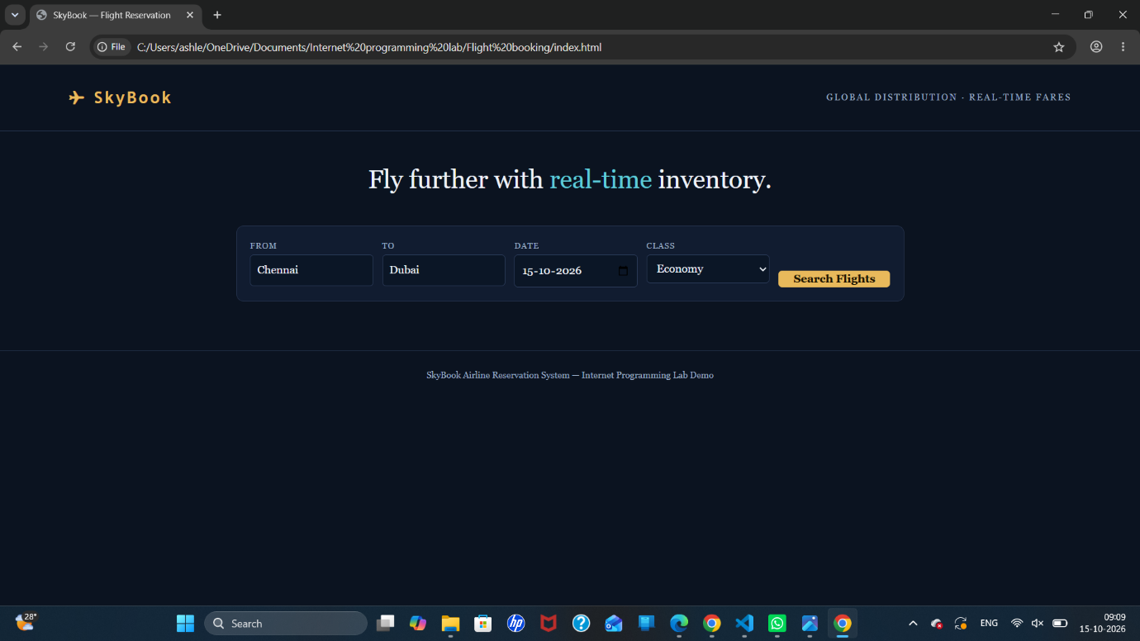

Result
Thus, the Flight Reservation webpage was developed successfully with flight search, airline selection, fare display, passenger details, and boarding pass generation.

